PROJECT REPORT
Project: SkillForge - AI Driven Adaptive Learning & Exam Generator
Author: Namita Sinha
Date: 12/December/2025
Milestone 2: Backend Integration with API calls

1. Milestone 2 Overview
Milestone 2 focuses on the successful integration of the frontend with a secure backend architecture, enabling real-time interaction between the user interface and server-side services. While Milestone 1 concentrated on UI/UX design and role-based dashboards, this milestone establishes the functional backbone of the platform through REST APIs, authentication mechanisms, and backend services.
This phase ensures that SkillForge AI transitions from a static UI prototype into a secure, role-aware, API-driven application, laying the foundation for adaptive learning intelligence and AI-powered exam generation in future milestones.
2. Backend Integration
2.1 Spring Boot Maven Backend Setup
The backend of SkillForge AI is developed using Spring Boot with Maven, following a clean and modular monolithic architecture. The backend handles authentication, user management, assessment operations, and secure data flow between system actors.
Key characteristics:
- RESTful API architecture
- Maven-based dependency management
- Layered design for scalability and maintainability
2.2 Frontend–Backend Communication
The React frontend communicates with the backend through HTTP REST APIs. Each role (Learner, Admin, Guardian) interacts with protected endpoints based on authorization rules.
- React uses fetch / axios to call backend APIs
- JSON-based request and response structure
- Environment-based API URLs for development
2.3 CORS and Configuration Management
To enable smooth communication between frontend and backend:
- CORS policies are configured in Spring Security
- Environment-based configurations prevent hardcoding
- Local development and production readiness ensured
3. Security Layer
3.1 JWT-Based Authentication
SkillForge AI uses JSON Web Tokens (JWT) for secure and stateless authentication.
Security flow:
- User logs in (Learner/Admin/Guardian)
- Backend validates credentials
- JWT token is generated with role-based claims
- Token is attached to subsequent API requests
- Backend filters requests using JWT validation
3.2 Role-Based Access Control
Each user role has restricted access:
- Learners access learning content and assessments
- Admins manage users, content, and performance
- Guardians monitor ward performance and analytics
JWT tokens embed role information to enforce authorization across controllers.
4. API Testing and Validation
4.1 Postman API Testing
Postman is used extensively to test backend endpoints before frontend integration.
Testing practices include:
- Centralized API collections
- Environment variables for base URLs and tokens
- Pre-request scripts to attach JWT tokens automatically
- Test scripts to validate status codes and responses
4.2 Live API Call Verification
The following API categories were tested successfully:
- User registration and authentication
- Secure login using JWT
- Dashboard data retrieval
- Course and assessment endpoints
Snapshots of successful API calls are documented as part of this milestone.
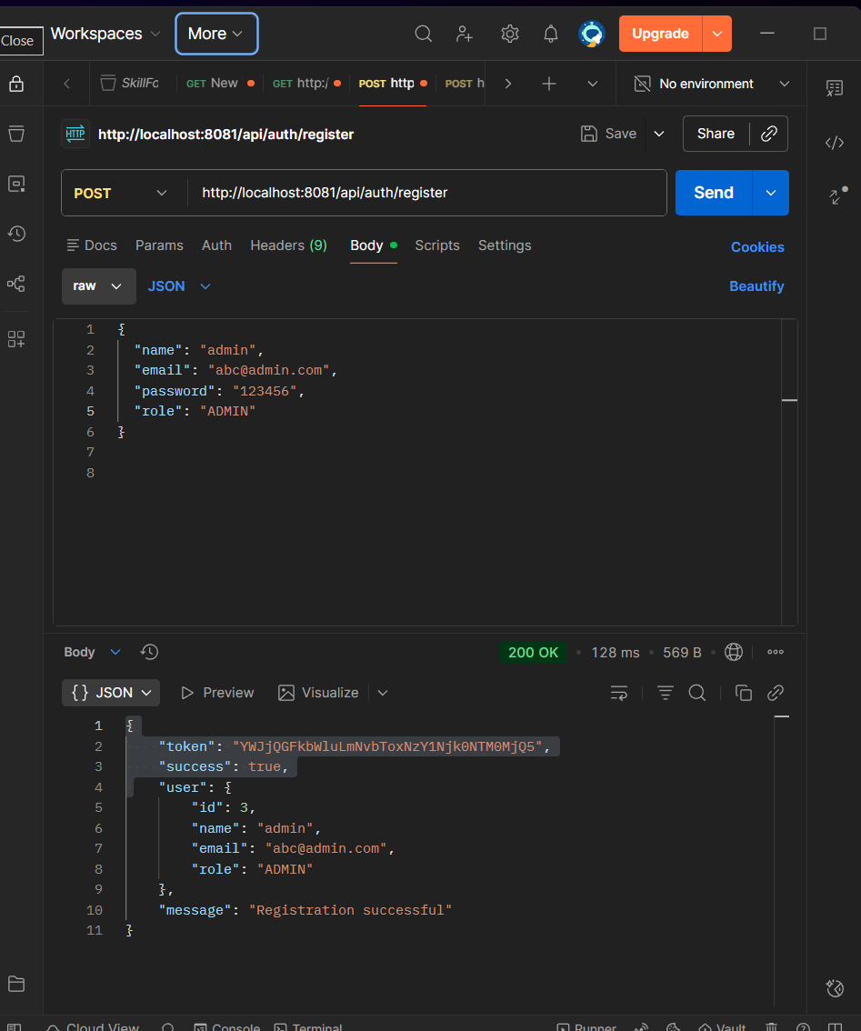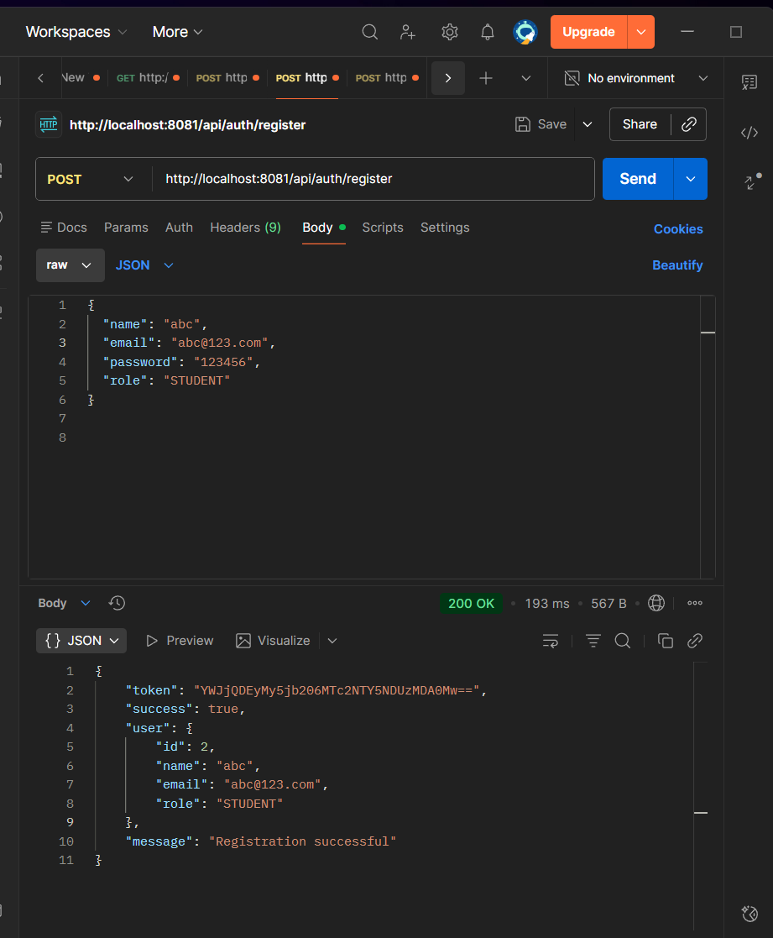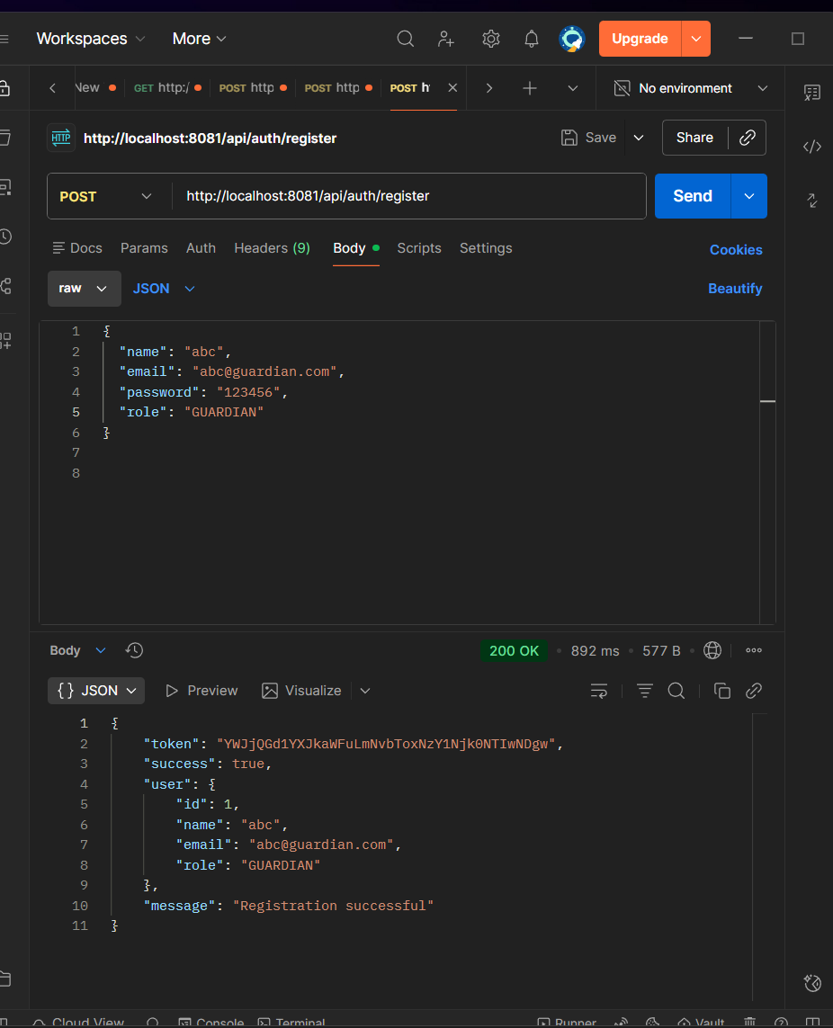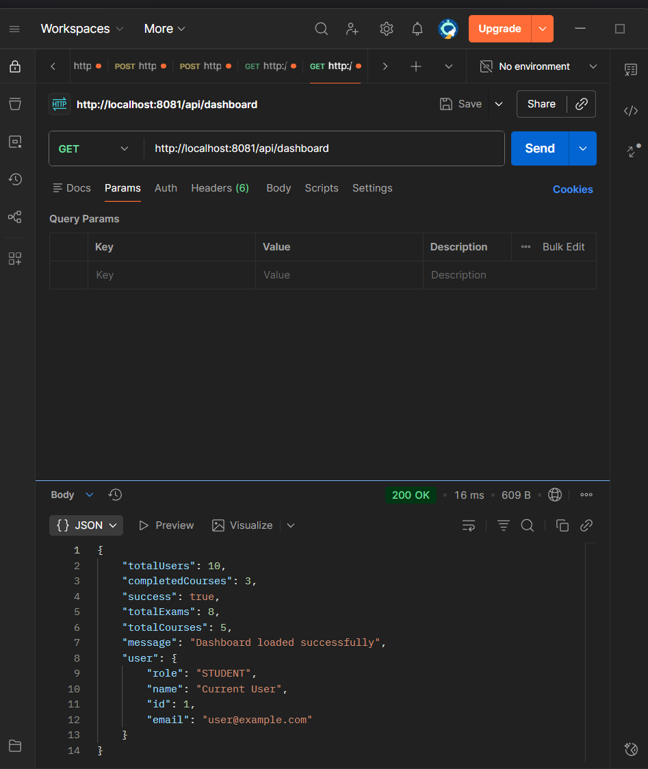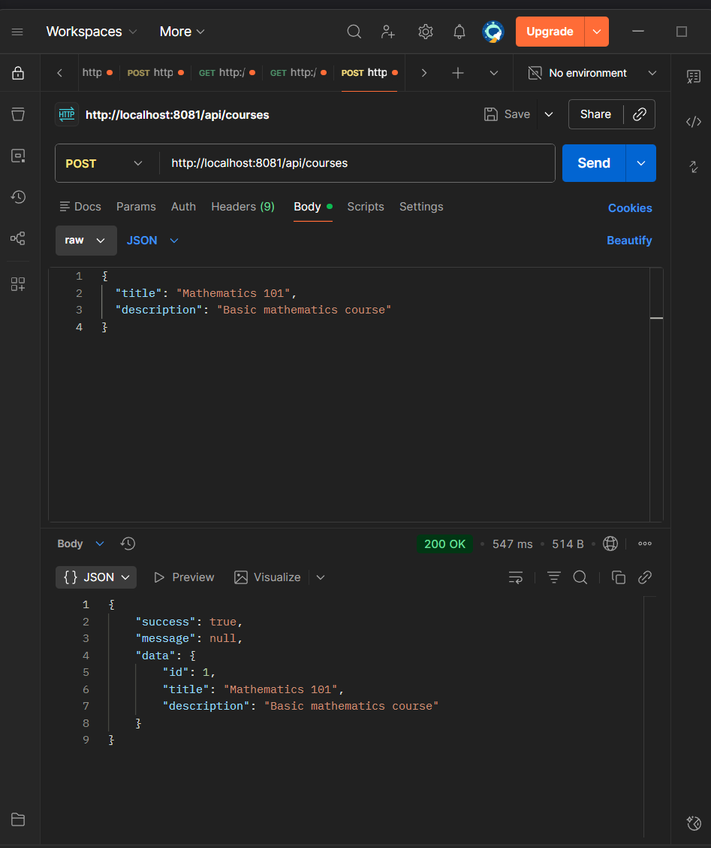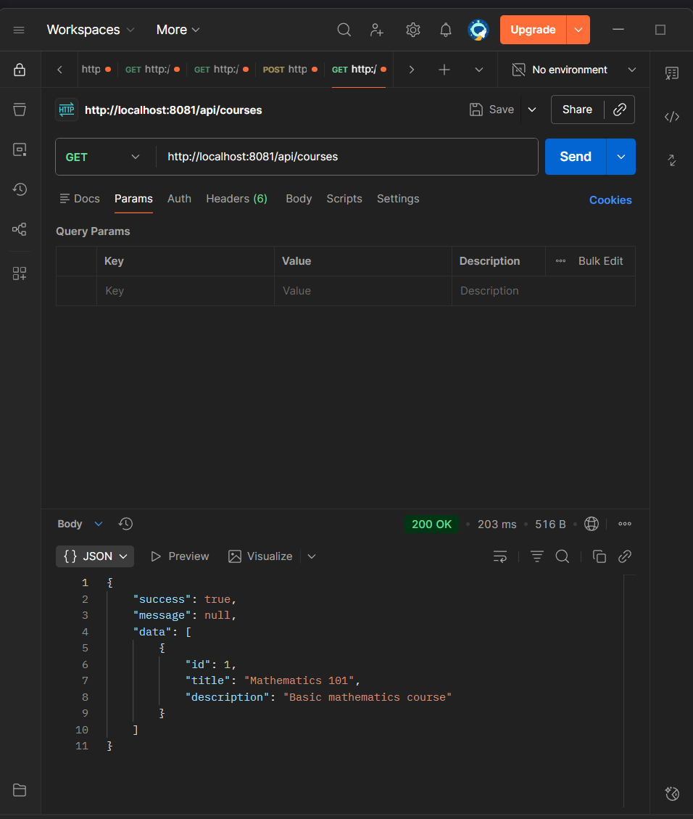
5. Challenges and Creative Solutions
5.1 Challenges Faced
- Synchronizing role-based routing between React and Spring Security
- JWT expiration affecting long learning sessions
- CORS conflicts during initial integration
- Maintaining clean API contracts during rapid iterations
5.2 Solutions Implemented
- Custom role guards in frontend routing
- Optimized token refresh handling
- Explicit CORS configuration
- Iterative refactoring of controllers and filters
These solutions ensured stability without compromising the platform’s minimal and professional UI/UX.
6. Milestone 2 Completion Status
6.1 Achievements
- Frontend successfully connected to backend
- Secure JWT authentication implemented
- Role-based access enforced
- APIs validated using Postman
- Backend architecture documented and structured
6.2 Readiness for Next Phase
With a stable backend integration in place, SkillForge AI is now ready to progress toward:
- AI-driven adaptive learning logic
- AI-based exam and assessment generation
- Advanced analytics and recommendation engines
- Database persistence and optimization

Conclusion
Milestone 2 marks a critical transition for SkillForge AI from a UI-focused prototype to a secure, API-driven learning platform. The integration of Spring Boot backend services with a polished React frontend, reinforced by JWT security and validated APIs, ensures a strong technical foundation. This milestone prepares the system for intelligent, AI-powered learning experiences in upcoming phases.

